Chapter 3
KE = ½ mu² E = hν C = λν h = 6.626 x 10⁻³⁴ J*sec C = 3.00 x 10⁸ m/sec

Threshold frequency is the frequency required to get an electron ejected from a metal’s surface. The Energy associated with threshold frequency is called binding energy. Once an electron is ejected from the metal’s surface it has kinetic energy. Total Energy = Binding Energy + Kinetic Energy see power point notes for more detail

- If the mass of an electron is 9.1 x 10⁻³¹ Kg. What must the wavelength of a photon be to eject an electron from a metal with a binding energy of 5.9 x 10⁻¹⁹J and have it travel at ½ the speed of light?

Total Energy = Binding Energy + Kinetic Energy

= 5.9 x 10⁻¹⁹ J + ½ (9.1 x 10⁻³¹ Kg) [(0.5)(3.00x 10⁸)]² = 1.0 x 10⁻¹⁴ J

1.0 x 10⁻¹⁴ = (6.626 x 10⁻³⁴)(3.0 x 10⁸) λ = 2.0 x 10⁻¹¹ m or 0.020 nm
λ

- What would the energy per mole be for photon with a frequency of 4.62 x 10¹⁴ Hz?

E = hν = (6.626 x 10⁻³⁴ J*sec)(4.62 x 10¹⁴ sec⁻¹) = 3.06 x 10⁻¹⁹ J x 6.022 x 10²³ photon = 1.84 x 10⁵ J/ mol
Photon photon 1 mole

- The binding energy of magnesium metal is 5.86 x 10⁻¹⁹J. Calculate the minimum frequency of light required to release an electron from the magnesium.

E = hν 5.86 x 10⁻¹⁹J = (6.626 x 10⁻³⁴ J*sec) ν ν = 8.84 x 10¹⁴ hz

- What is the kinetic energy of an ejected electron in problem 3 if a photon with a wavelength of 150 nM is used to irradiate the magnesium metal?

Total Energy = Binding Energy + Kinetic Energy

E = hC = (6.626 x 10⁻³⁴)(3.0 x 10⁸) = 1.3 x 10⁻¹⁸ J = 5.86 x 10⁻¹⁹ J + Kinetic Energy
λ 1.5 x 10⁻⁷ m

Kinetic Energy = 7.4 x 10⁻¹⁹ J

Bohr’s Theory: When the electrons in an atom are excited. They emit a certain wavelength of light when they return to ground state. Each element has their own unique emission spectrum. For example Sodium metal emits a single yellow wavelength which is known as sodium D light
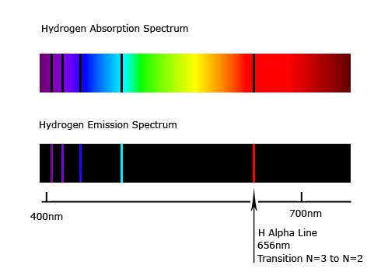

Absorption Spectrum is:
What wavelengths of light are absorbed by an element

Emission Spectrum is:
What wavelengths are emitted by an element

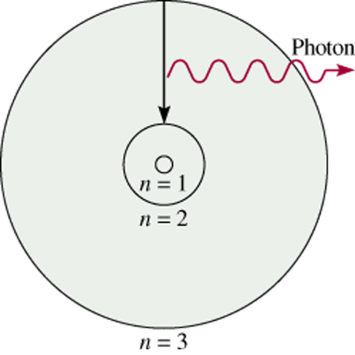
Bohr’s Theory:
- e_ can only have specific (quantized) energy values
- light is emitted as e_ moves from one energy level to a lower energy level

E = -b
n²
b = 2.18 x 10⁻¹⁸ J

ΔE = E_{f} - E_{i}
1n
( )
1
n
i
f
-
2
2
ΔE = - b

de Broglie Hypothesis:
If substances that behave like waves have particle characteristics than particles could also have wave characteristics.
λ = h
mu
m = mass in Kg
u = velocity in m/sec

- What is the de Broglie wavelength in nm of a 2.5 gram ping-pong ball traveling at 15.6 m/sec?

λ = h 6.626 X 10⁻³⁴ J*sec = 1.7 x 10⁻³² m
mu (2.5 x 10⁻³ Kg) (15.6 m/sec)

- What is the de Broglie wavelength in nm of an electron traveling at 10% of the speed of light?

λ = h 6.626 X 10⁻³⁴ J*sec = 2.4 x 10⁻¹¹ m
mu (9.1 x 10⁻³¹ Kg) (0.1 x 3.0 x 10⁸ m/sec)

What are the differences between 1 and 2?

The ping pong ball has a wavelength outside of the electromagnetic spectrum because it is so large of an object while the electron has a wavelength within the electromagnetic spectrum because it is so small

Heisenberg’s Uncertainty Principle:

The position and Energy of an electron cannot be precisely defined.

The more accurately we know the position the more uncertain we are about energy

